**COMSATS UNIVERSITY ISLAMABAD LAHORE CAMPUS**

**Activity no 9**

IRAM SHAHZADI

FA24-BBA-120

**Question 1:**

Write a program to check if a number is positive, negative or zero

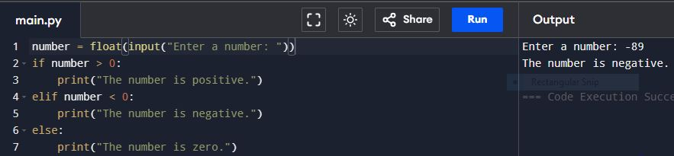

**Question 2:**

Create a program to determine whether a given year is a leap year.

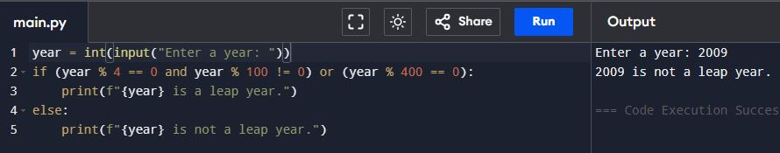

**Question 3:**

Build a simple calculator that ask for two numbers and an operator (+,-,*,/ ) and a points the result.

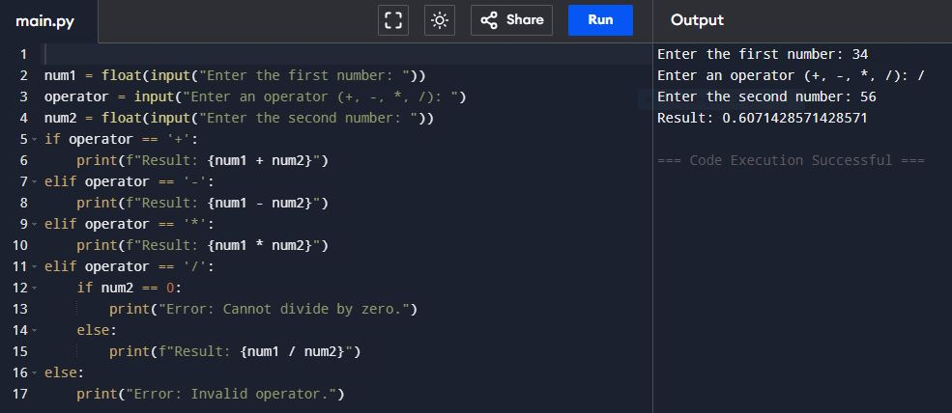

**Question 4:**

Write a python program that accepts a student’s marks and points the appropriate grade based on the following criteria:

1. 85 and above c) 70 to 84
2. 70 to 84 f) Below 50

